12. Demonstrate virtualization by Installing Type-2 Hypervisor in your device, create and
configure VM image with a Host Operating system (Either Windows/Linux), using VMware
workstation.
Aim: To demonstrate virtualization by installing a Type-2 Hypervisor (Oracle VirtualBox) on a host system and creating, configuring, and running a Virtual Machine (VM) with a guest operating system (Windows/Linux).
Procedure:
- Download VMware Workstation from the official VMware website and install it on the host system.
- Download the Guest Operating System ISO file (Windows or Linux, e.g., Ubuntu) from its official website.
- Launch VMware Workstation after successful installation.
- Click on Create a New Virtual Machine.
- Select Typical (Recommended) and click Next.
- Choose Installer disc image file (ISO) and browse to select the downloaded OS ISO file.
- Select the Guest Operating System type and version.
- Provide a Virtual Machine name and choose a location to store VM files.
- Allocate hardware resources:
- Processor: 1 CPU
- Memory: 2 GB RAM
- Storage: 15 GB virtual disk
- Click Finish to create the virtual machine.
- Power on the virtual machine and follow the on-screen steps to install the guest operating system.
- After installation, install VMware Tools for better performance and display resolution.
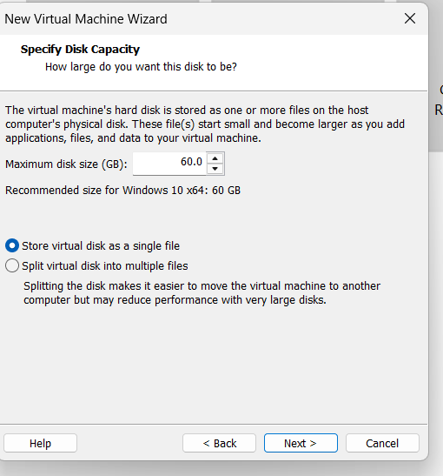
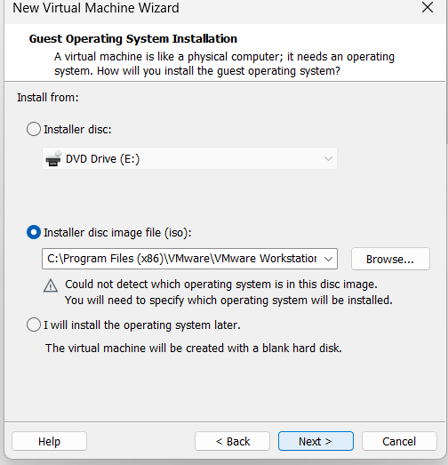
Output:
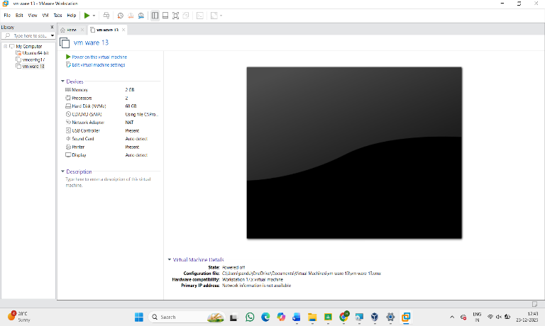
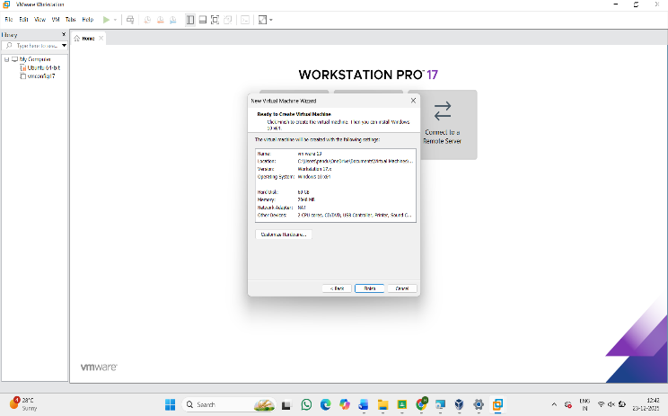
Result: Thus, virtualization was successfully demonstrated by installing VMware Workstation (Type-2 Hypervisor) and creating a virtual machine with a guest operating system. The virtual system operated independently within the host machine, proving the concept of virtualization.

